**Quiz Website**

**Participants name:**

1. Jatin Maurya
2. Henil Davariya
3. Falguni Solanki

|  |  |
| --- | --- |
| Introduction | Elephanta Quiz |
| Uses | You can create quiz |
| Features | Create, edit, modify and dashboard |
| Technology used | Html, CSS, JS, Node.js, Express Js, Mongo DB |

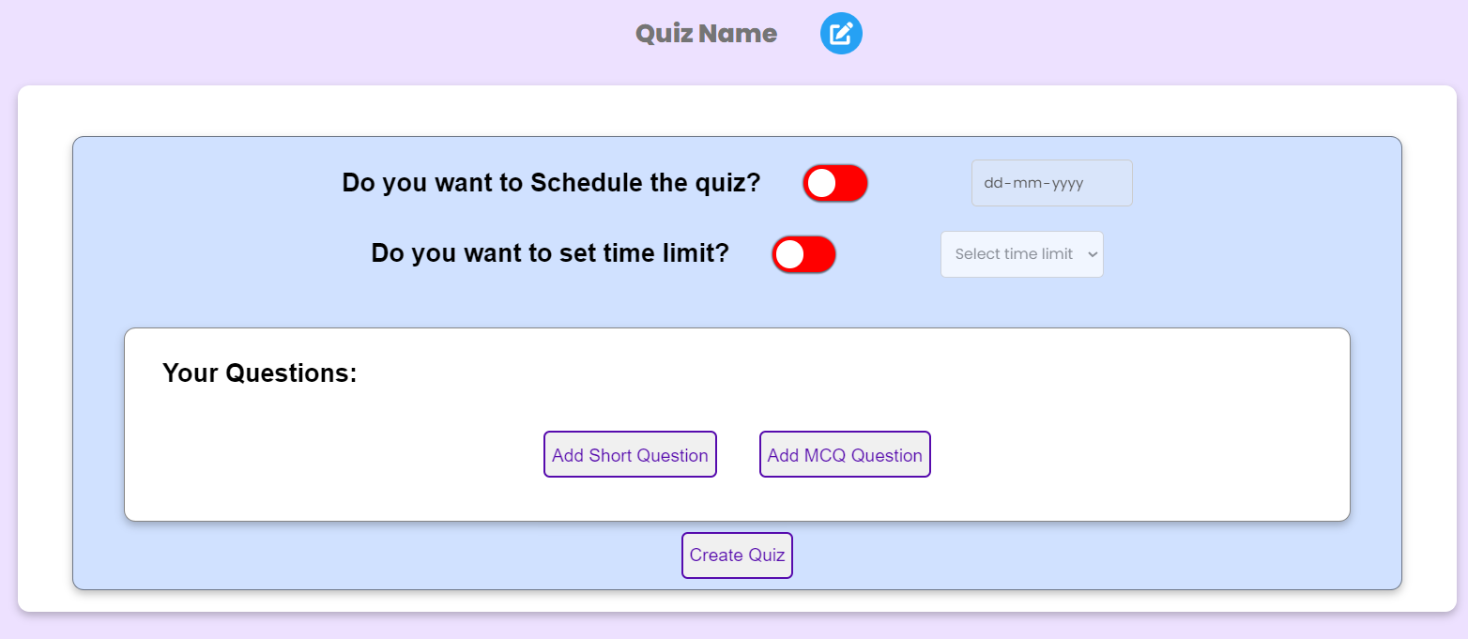**Create Quiz Page**

Here you can create quiz dynamically and there are many other options like to schedule quiz, set time limit and to add short and mcq types questions.

**Highlights**

* Developed a feature-rich quiz website allowing users to create, schedule, and manage quizzes with real-time tracking and validation.
* Implemented advanced functionalities such as time limits per question, read-only mode for created quizzes, and an automatic profile update feature.
* Integrated a robust customer support page with validation to ensure the submission of only valid queries.

**Features**

* Create Quiz
* Check the quiz created
* Check the time and date of creation
* Check the number of quizzes you have created
* Delete the created quiz
* You can add short and MCQ questions in the form

**Tech – Stack**

* HTML
* CSS
* Java Script
* Mongo DB
* Node.js
* Express Js